mysql> use myd;

Database changed

mysql> select*from sornesh;

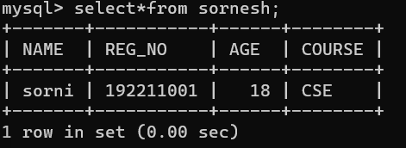

mysql> insert into sornesh Values('sornesh', 192211052,17,'EEE');

Query OK, 1 row affected (0.01 sec)

mysql> insert into sornesh Values('kathir',192211011,18,'EEC');

Query OK, 1 row affected (0.01 sec)

mysql> insert into sornesh Values('cholan', 192211059,19,'IT');

Query OK, 1 row affected (0.01 sec)

mysql> select*from sornesh;

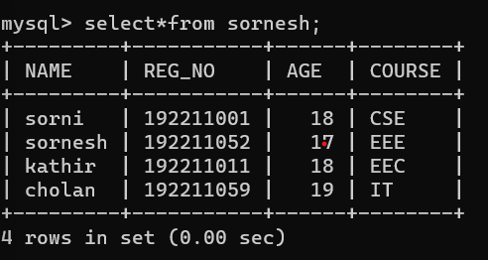

mysql> select*from sornesh where age>=18;

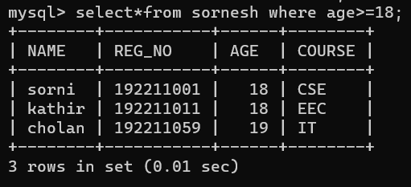

mysql> select age from sornesh where age between 17 and 20;

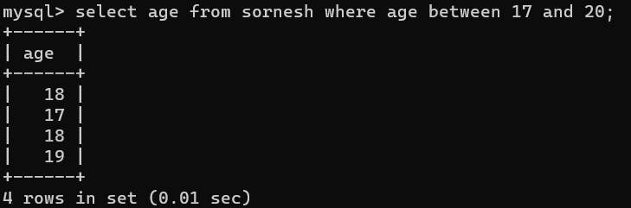

mysql> select reg_no from sornesh where reg_no in (1,2);

Empty set (0.01 sec)

mysql> select reg_no from sornesh where reg_no in (192211052,192211059);

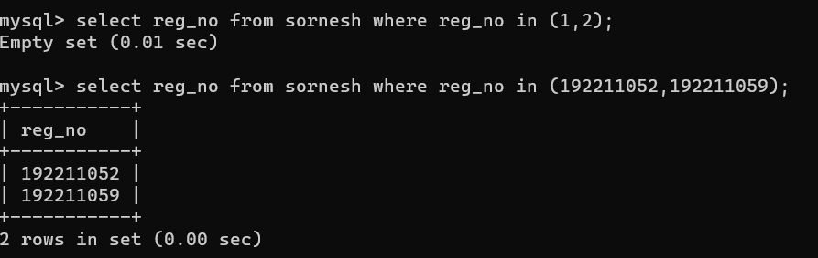

mysql> select reg_no from sornesh order by reg_no asc;

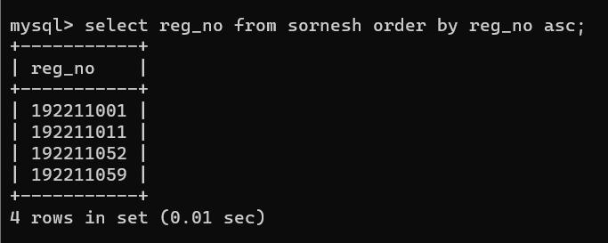

mysql> select reg_no from sornesh where age>=18 group by reg_no ;

